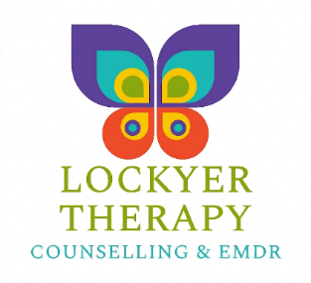
Safeguarding Policy
Lockyer Therapy is committed to safeguarding and promoting the wellbeing of clients.
Appropriate safeguarding action may be taken where there are concerns relating to:
- risk of suicide or serious self-harm
- abuse or neglect
- risk to children or vulnerable adults
- serious risk to others
Where appropriate and possible, safeguarding concerns will be discussed collaboratively with clients.

